RESTRICTED
ORDNANCE PAMPHLET 866

(FIRST REVISION)
DEPTH CHARGE, MARK 9
AND MODIFICATIONS
DESCRIPTION AND INSTRUCTIONS FOR USE

12 FEBRUARY 1944

This publication is RESTRICTED and will be handled in accordance with Article 16, United States Navy Regulations, 1920
2
This page is blank.
3
NAVY DEPARTMENT
BUREAU OF ORDNANCE
WASHINGTON, D. C.
12 February 1944
RESTRICTED
ORDNANCE PAMPHLET NO. 866 (FIRST REVISION)
DEPTH CHARGE MARK 9 AND MODIFICATIONS - DESCRIPTION AND INSTRUCTIONS FOR USE.
1. Ordnance Pamphlet No. 866 (First Revision) contains a description and instructions for use of the Mark 9, Mark 9 Mod. 1 and Mark 9 Mod. 2 Depth Charges.
2. This publication supersedes Ordnance Pamphlet No. 866, which should be destroyed.
3. It is not intended that this publication be carried in aircraft for use therein.
4. This publication is RESTRICTED and is to be handled in accordance with the provisions of article 76, Navy Regulations, 1920.
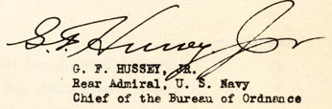
4
CONTENTS
CHAPTER 1 | Page
Introduction | 7
General | 7
Table 1 | 12
CHAPTER 2
Description of Depth Charge Cases Mark 9 and Modifications | 15
Depth Charge Case Mark 9 | 15
Depth Charge Case Mark 9 Mod. 1 | 15
Depth Charge Case Mark 9 Mod. 2 | 17
CHAPTER 3
Pistols
Mark 6 and Mark 6 Mod. 1 | 19
Mark 7 Mod. 1 | 23
Depth Setting Wrench | 25
How It Works | 27
CHAPTER 4
Loading, Stowing and Handling Depth Charge Cases and Pistols | 33
Loading the Cases | 33
Stowing and Handling the Cases | 34
Depth Charge Pistols and Booster Extenders Mark 6 and Mark 6 Mod. 1 | 34
Depth Charge Pistols Mark 7 Mod. 1 | 34

5
CHAPTER 5 | Page
Installing Pistol into Case | 35
Depth Charge Pistol Mark 6 or Mark 6 Mod. 1 | 35
Depth Charge Pistol Mark 7 Mod. 1 | 35
CHAPTER 6
Instructions for Use of Depth Charges Mk. 9 and Modifications | 41
Dropping from a Release Track | 41
Firing from a Projector | 43
CHAPTER 7
Operational Characteristics of Depth Charge Mk. 9 and Modifications | 49
Launching Speeds | 49
Pistol Firing Depths | 51
Projection Ranges | 52
APPENDIX A
APPENDIX A | 53

6
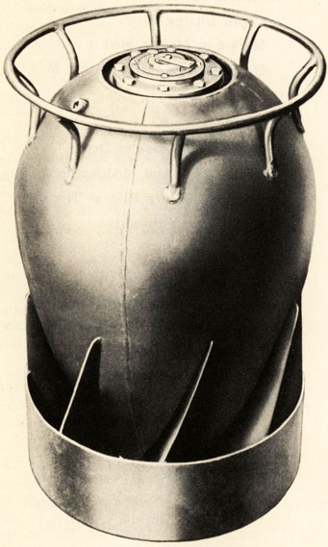
DEPTH CHARGE MARK 9
7
INTRODUCTION | CHAPTER 1

GENERAL
1.1 Depth Charges Mark 9 and modifications are teardropshaped, anti-submarine weapons which have higher sinking speeds and more stable underwater flight characteristics than the cylindrical, symmetrically-loaded Depth Charges Mark 6 and Mark 7 and modifications. These improved characteristics permit greater attack accuracy than has been possible in the past.
1.2 In order to launch these teardrop shaped charges from existing tracks, it is necessary to modify most tracks in accordance with Bureau of Ordnance Circular Letter M5-45 so that the pawls and detents will control the charges.
1.3 To project these charges from a projector, it is necessary to use an arbor which will separate from the depth charge after the projector is fired to take advantage of the characteristic underwater trajectory and sinking speed of the charge. Depth Charge Arbors Mark 7 and Mark 7 Mod. 1 were designed for this purpose.
1.4 There are three streamlined, teardrop shaped depth charges, the Mark 9, Mark 9 Mod. 1 and Mark 9 Mod. 2. Table 1 summarizes pertinate information regarding these charges.
1.5 Depth Charge Pistols Mark 6 and Mark 6 Mod. 1 are the only pistols suitable for use in the Depth Charge Mark 9. Depth Charge Pistols Mark 6, Mark 6 Mod. 1, or Mark 7 Mod. 1 may be used in Depth Charges Mark 9 Mod. 1 and Mark 9 Mod. 2. In all instances, the pistol is mounted in the nose of the depth charge case, and the Depth Charge Booster-Extender Mark 6 or Mark 6 Mod. 1, which is used with the Pistol Mark 6 or Mark 6 Mod. 1, is placed in the aft end of the charge case.
8
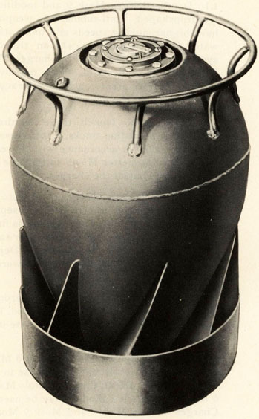
DEPTH CHARGE MARK 9 MOD, 1
9
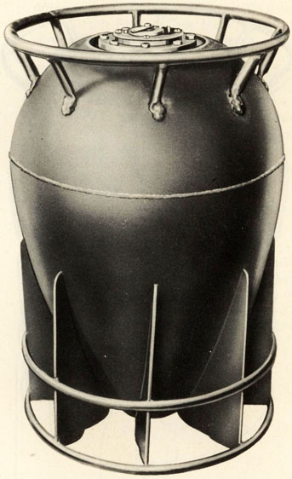
DEPTH CHARGE MARK 9 MOD, 2
10
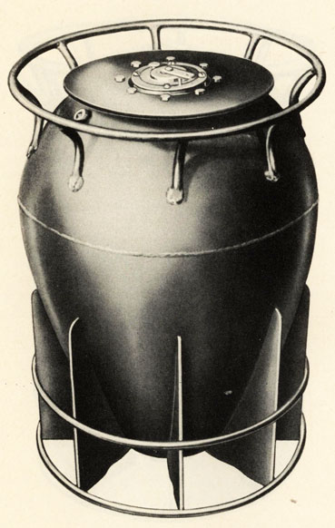
DEPTH CHARGE MARK 9 MOD, 2 WITH SPOILER PLATE
11
SPOILER PLATE
1.6 The performance characteristics and physical outline of the Depth Charge Mark 9 Mod. 1 do not differ from those for the Depth Charge Mark 9. (The Depth Charge Case Mark 9 Mod. 1 is fabricated differently than the Depth Charge Case Mark 9.) It is to be noted that the faster sinking Depth Charge Mark 9 Mod. 2 can be distinguished easily from the other charges by means of its straight fins and the substitution of two rings for the tail shroud that appears on the Depth Charges Mark 9 and Mark 9 Mod. 1 It is important that the Depth Charge Mark 9 Mod. 2 be recognized due to its faster sinking speed and the resulting greater launching speed required for the launching vessel when this charge is stern dropped and set to fire at shallow depths. (See Chapter 7 for launching speed tables.)
1.7 In situations where the advantage of high sinking speed of the Depth Charge Mark 9 Mod. 2 is desired but where the launching speed requirements cannot be met, spoiler plates are used to reduce the sinking rate of this charge from 22.7 ft./sec. to 20 or to 15 ft./sec. These spoiler plates are fastened to the nose of the case over the pistol using the pistol cap bolts.
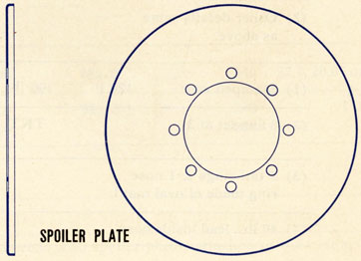
Pages 12 and 13
TABLE 1

DEPTH  CHARGE  CASE | CASE DETAILS | CASE  WGT.  (EMPTY) | EXPLOSIVE  CHARGE  WEIGHT | PISTOL | PISTOL  DEPTH  SETTING  RANGE (FT.) | BOOSTER-  EXTENDER | ASSEMBLED  OVERALL  WEIGHT | AVERAGE  TERMINAL  SINKING  SPEED
MK. 9 | (1) 8 fins set at 20 | 90 lbs. | 200 lbs.  TNT | Mk. 6  Mk. 6-1 | 30 - 300  30 - 600 | Mk. 6  Mk. 6-1 | 320  320 | 14.5
MK. 9 | (2) 6" shroud on tail
MK. 9 | (3) Nose ring of round mat'l.
MK. 9 | (4) Fore and aft welded case.
MK. 9  MOD. 1 | (1) Stamped case welded circumferentially | 90 lbs, | 200 lbs.  TNT | Mk. 6  Mk. 6-1  Mk. 7-1 | 30 - 300  30 - 600  50 - 500 | Mk. 6  Mk. 6-1 | 320  320  310 | 14.5
MK. 9  MOD. 1 | (2) Other details same as above.
MK. 9  MOD. 2 | (1) Stamped case | 120 lbs. | 190 lbs. | Mk. 6 | 30 - 300 | Mk. 6 | 340 | 22.7, 20.0* or 15*
MK. 9  MOD. 2 | (2) 8 fins set at 3 |  | TNT | Mk. 6-1  Mk. 7-1 | 30 - 600  50 - 500 | Mk. 6-1 | 340  330
MK. 9  MOD. 2 | (3) 2 tail rings & 1 nose ring made of oval mat'l.
MK. 9  MOD. 2 | (4) 40 lbs. lead inside nose.

* Sinking speeds with spoiler plates attached to the case nose.
14
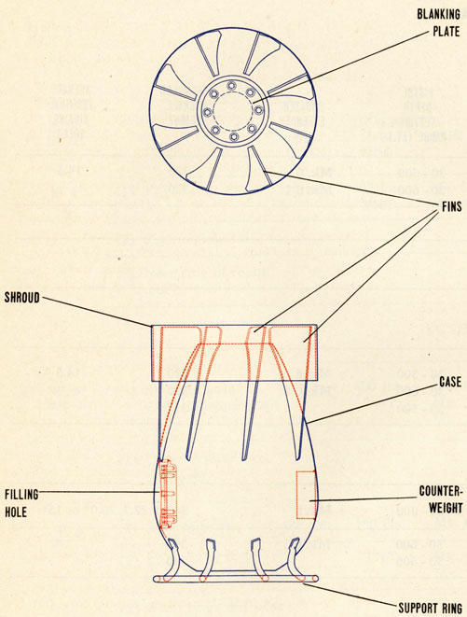
DEPTH CHARGE CASE MARK 9
15
DESCRIPTION | CHAPTER 2

DESCRIPTION OF DEPTH CHARGE CASES MARK 9 AND MODIFICATIONS
2.1 The Depth Charge Mark 9 or its modifications consists of a depth charge case, a depth charge pistol, and an appropriate depth charge booster-extender as necessary.
2.2 Depth Charge Case Mark 9 has a maximum length of 27.625 inches and a maximum diameter of 17.640 inches. A support ring, 1/2-inch-diameter, is secured to the nose or forward end of the case by eight brackets. Eight fins are secured along the after end and are set at an angle of 20 degrees to the longitudinal axis of the case. The rotation of the case as it sinks is due to the fins and improves the underwater trajectory. A shroud or support band is fastened to the outer edges of these fins. When the depth charge is installed in a release track, its weight is carried by the support ring and shroud resting on the lower rails of the tracks.
FILLING HOLE
2.3 A filling hole is provided in the side for loading the explosive charge into the case. A flat steel plate is secured to the flange of the hole after the case is loaded, and a domed cover is then secured to this plate. The domed cover has the same contour as the case to preserve the continuity of the stream-lining. A central tube, approximately 24.750 inches long and 4.175 inches inside diameter, extends through the length of the case.
DEPTH CHARGE CASE MARK 9 MOD. 1
2.4. Depth Charge Case Mark 9 Mod. 1 differs from the Depth Charge Case Mark 9 only in the details of construction. The case is of stamped shell construction which is welded circumferentially rather than the "orange peel" fabrication welded fore and aft. None of these changes has any effect on the handling, operation, or characteristics of the depth charge.
16
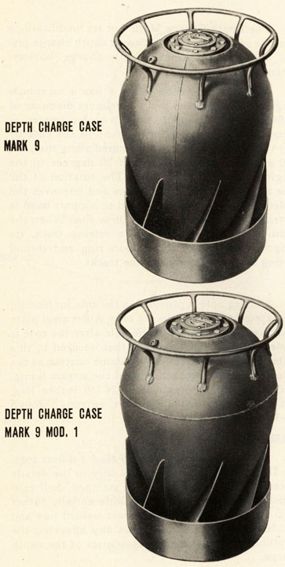
17
THE CASES
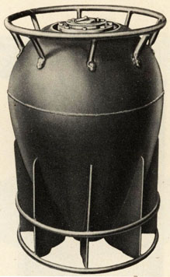
DEPTH CHARGE CASE MARK 9 MOD, 2
DEPTH CHARGE CASE MARK 9 MOD. 2
2.5 Depth Charge Case Mark 9 Mod. 2 differs from the Depth Charge Case Mark 9 chiefly in that the tail shroud is replaced by two rings and the angle of the fins to the longitudinal axis of the case has been reduced from 20' to 3'. The tail rings, the nose ring and nose ring supports have been made oval in cross section to reduce water resistance. The loading hole has been redesigned to facilitate loading the case. The nose of the depth charge case is weighted with 40 pounds of lead. These changes give the Depth Charge Mark 9 Mod. 2 a terminal sinking velocity considerably greater than that of the Depth Charges Mark 9 and Mark 9 Mod. 1.
18
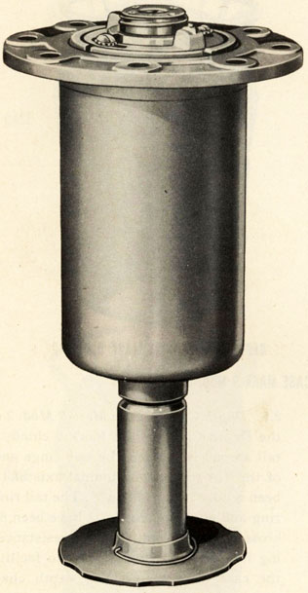
DEPTH CHARGE PISTOL MARK 6 MOD. 1 ASSEMBLED
19
PISTOLS | CHAPTER 3

DEPTH CHARGE PISTOLS, MK. 6 AND MK. 6 MOD. 1
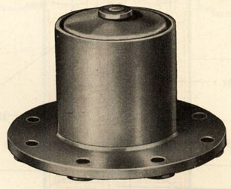
DEPTH CHARGE BOOSTER EXTENDER MARK 6
DEPTH CHARGE PISTOLS MARK 6 AND MARK 6 MOD. 1
3.1 Depth Charge Pistols Mark 6 and Mark 6 Mod. 1 A description of and instructions for testing Depth Charge Pistols and Booster Extenders Mark 6 and Mark 6 Mod. 1 are contained in O.P. No. 747 (First Revision). Refer to this publication if these mechanisms are to be used.
20
GENERAL ARRANGEMENT
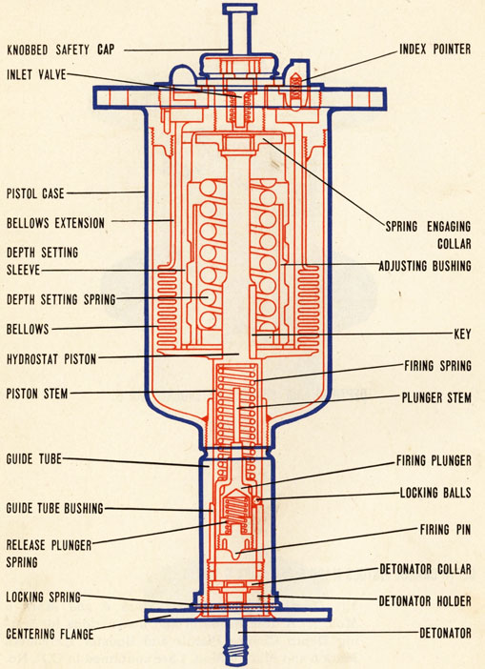
DEPTH CHARGE PISTOL MARK 6
21
DEPTH CHARGE PISTOLS, MK. 6 AND MK. 6 MOD. 1
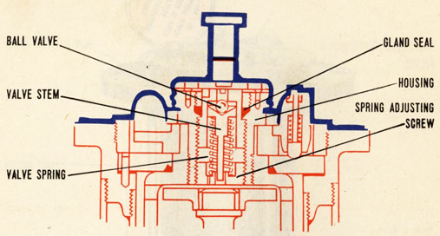
DEEP FIRING MECHANISM DEPTH CHARGE PISTOL MK. 6 MOD. 1
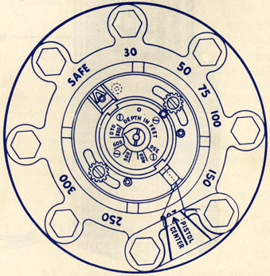
TOP OF DEPTH CHARGE PISTOL MARK 6 MOD. 1
22
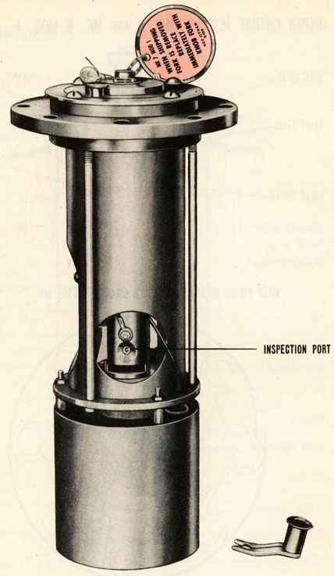
DEPTH CHARGE PISTOL MARK 7 MOD, 1
23
DEPTH CHARGE PISTOL MARK 1 MOD. 1
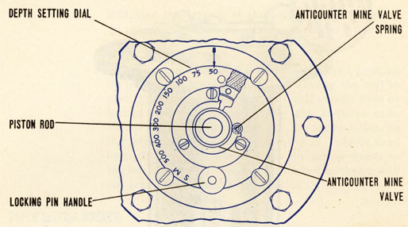
TOP OF DEPTH CHARGE PISTOL MARK 7 MOD, 1
3.2 The Depth Charge Pistol Mark 7 Mod. 1 is a complete primary explosive unit containing detonators and boosters. This pistol must be handled as live ammunition and shall not be disassembled or tested in any way after issue. No accessories are required with the Depth Charge Pistol Mark 7 Mod. 1 for hydrostatic firing.
3.3 The pistol is designed to arm at a depth of approximately 45 feet by hydrostatic action. It may be set to operate as follows:
(a) For firing at predetermined depth between 50 and 500 feet.
(b) On Safe so that it will not arm or fire at any depth.
3.4 A dial set into the pistol flange adjusts the depth setting at which the pistol operates. An arrow scribed in the flange at the outer edge of the dial
24
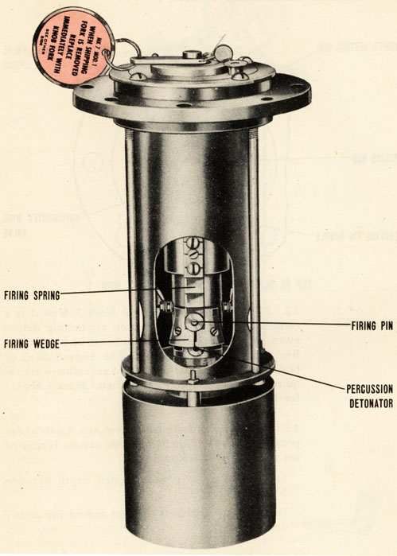
DEPTH CHARGE PISTOL MARK 7 MOD, 1
25
DEPTH CHARGE PISTOL MARK 1 MOD. 1
indicates the setting of the pistol. Figures scribed on the dial indicate the depths in feet at which the pistol may be fired by hydrostatic pressure.
3.5 The dial can be rotated to the desired position by lifting the knurled knob and turning the dial to match the arrow and figure. The dial should then be locked in place by permitting the knob to seat. When the dial is turned so that the arrow points to the letter M, the pistol can arm but will not be fired by hydrostatic pressure. When the arrow points to the letter S (safe), the pistol is locked so that it will not arm or fire under any conditions.
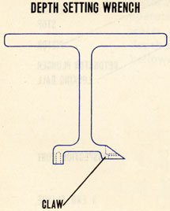
3.6 A depth-setting wrench will be issued to facilitate setting Depth Charge Pistols Mark 7 Mod. 1 which become difficult to set by hand. This wrench has a claw which fits under the knurled knob of the depth-setting dial locking pin, a socket which fits over the fixed pin protruding from the dial on the opposite side, and a T-shaped handle. To use the wrench, slip the forked claw under the locking pin knob, then push the socket down over the fixed pin. This will pull the locking pin out and allow the setting dial to be turned with the wrench handle.
3.7 As long as a safety fork is in place on the pistol, or the pistol is set at safe, inward motion of the piston rod is prevented and the pistol is locked safe. In this position the explosive train contained in the detonator plunger and sub-booster carrier, which is composed of tetryl lead-in charges from the
26
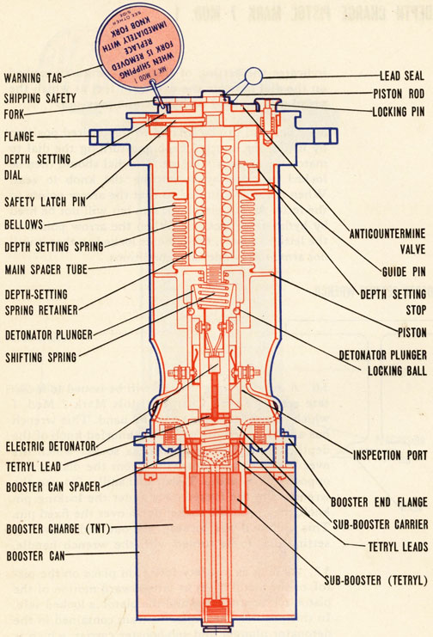
SECTIONAL VIEW DEPTH CHARGE PISTOL MARK 7 MOD, 1
27
DEPTH CHARGE PISTOL MARK 1 MOD. 1
detonators to the booster, is interrupted by misalignment of these elements. Furthermore, the firing pin is held away from the percussion detonator. Since both the electric and the percussion detonators must fire through the same tetryl leads to set off the sub-booster, firing of either detonator will not set off the sub-booster or booster.
HOW IT WORKS
3.8 How the Depth Charge Pistol Mark 7 Mod. 1 Works. The depth charge is dropped or thrown overboard. At the same time the safety fork on the pistol is wiped or pulled off and the pistol is free to operate by hydrostatic action. As the charge sinks, water enters the pistol through ports inside the depth setting dial and flows into the space inside the bellows, flange, and depth-setting spring retainer.
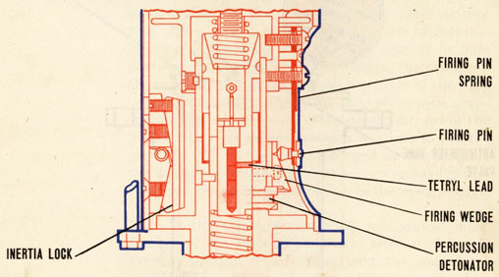
FIRING PIN AND PERCUSSION DETONATOR
(SECTION 90° FROM SECTION SHOWN ON PAGE 26)
28
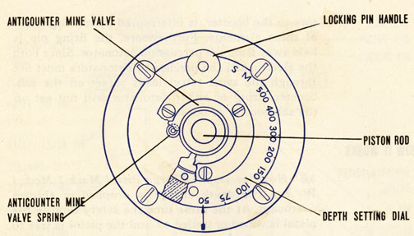
TOP VIEW OF DEPTH CHARGE PISTOL MARK 7 MOD. 1
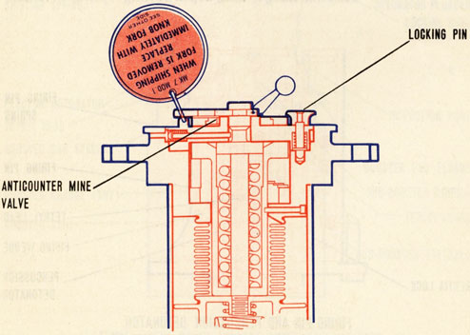
29
DEPTH CHARGE PISTOL MARK 1 MOD. 1
3.9 The pistol is armed by hydrostatic pressure upon the bellows which forces the piston and piston rod to move inward. The motion of the piston compresses the shifting spring between the piston and the detonator plunger. When the piston has moved approximately 1/4-inch, the locking balls in the sub-booster carrier (which is fixed in position by the main spacer tube) slip out into the enlarged section of the piston. The shifting spring then forces the detonator plunger against a stop in the sub-booster carrier. In this position the tetryl leads in the plunger and carrier are aligned. The pistol is armed as the explosive train is now continuous from detonator to the booster. It cannot be returned to the unarmed position without being disassembled because the locking balls in the enlarged section of the piston are prevented from returning to original position.
3.10 Further inward motion of the piston rod causes a shoulder on the rod to come up against the depth-setting spring. The point at which this occurs is controlled by the position of the depth-setting stop. This, in turn, is determined by the adjustment of the depth-setting dial to other than M or Safe position. As the piston moves inward, the firing pin slides up the firing wedge until it is clear of the high point of the wedge. The firing pin spring then snaps the pin against the percussion detonator, firing the pistol. The hydrostatic pressure required to fire the pistol in this manner is determined by the distance the depth-setting spring must be compressed before the firing pin slides past the end of the firing wedge.
3.11 If the pistol is set on M, mechanical interference of the parts in the pistol after arming will prevent the pin from sliding past the end of the wedge. This prevents the pistol from being fired by hydrostatic pressure.
30
3.12 To prevent this pistol from arming prematurely by shock after the safety fork has been removed, the Depth Charge Pistol Mark 7 Mod. 1 is equipped with an inertia lock. This lock consists of a rocker arm mounted on the inside of the spacer tube. The location of the center of gravity of the rocker arm is such that any shock in the direction which would tend to arm or fire the pistol will cause the arm to fly out and momentarily lock the piston in the safe position. Under normal conditions the rocker arm is held clear of the piston by a light spring.
3.13 To prevent premature mechanical firing of the pistol if an explosion should occur close to the depth charge after it is in the water, an anticountermine valve is fitted over the inlet ports in the depth-setting dial. This valve is held in position over the ports by a ring secured to the dial. It is held away from the ports during normal operation by small springs between the valve and the dial. If a sudden increase in pressure (such as would be caused by an explosion close to the pistol) occurs, the valve is designed to move inward against the pressure of the springs. This closes the ports until the pressure returns to normal. The gradual hydrostatic pressure increase which takes place as the depth charge sinks will not close the ports.
3.14 Safety Measures for the Depth Charge Pistol Mark 7 Mod. 1 The Depth Charge Pistol Mark 7 Mod. 1 is assembled at a loading station with all of its explosive components (detonators, tetryl leads, sub-booster and booster) in place. Therefore it must be handled as live ammunition and shall not be disassembled or tested in any way after it is issued for service. This pistol is to be installed in a depth charge only after the charge has been placed in a
31
DEPTH CHARGE PISTOL MARK 1 MOD. 1
track, projector, or projector rack. A damaged or faulty pistol, or one which becomes armed prematurely, shall be disposed of as suggested in paragraph 5.8.
3.15 The pistol must be checked, prior to assembly of the depth charge, by inspection of the port in the sleeve of the sub-booster carrier. The letters A and C are scribed on the surface of the detonator plunger. When the letter A is visible through the port the pistol is armed. When the letter C is visible through the port, the pistol is cocked and is not armed.
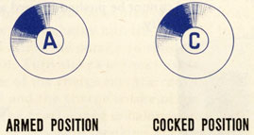
3.16 A Depth Charge Pistol Mark 7 Mod. 1 must never be installed in a depth charge case if the pistol is in the armed condition. An armed pistol should be disposed of as suggested in paragraph 5.8
3.17 After the pistol has been installed in a depth charge, its condition can be determined by noting the position of the exposed end of the piston rod. If a safety fork can be placed on it, the pistol is not armed. Should the pistol become armed as shown by the pistol spindle being flush with the flange body, the pistol should be carefully removed and replaced.
32
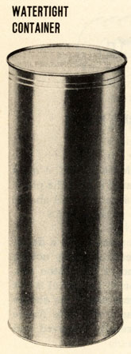
3.18 The Depth Charge Pistol Mark 7 Mod. 1 is loaded and assembled at the loading depot and is issued for service in a cylindrical water-tight metal container with a tear strip for opening around one end. The tear strip may be removed with ordinary pliers by pulling on the exposed metal tab. This allows the pistol to be taken out of the can. The container should not be opened until the pistol is to be installed in a depth charge case. Each pistol will be fitted with a shipping safety fork, secured in place with a wire-and-lead seal. One knobbed safety fork and a pistol flange gasket will be packed in the container with each pistol. In changing from the shipping fork to the knobbed fork care should be taken to set the pistol on Safe in order that the piston rod cannot be pushed inward and arm the pistol accidentally.
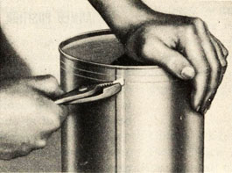
TEAR STRIP FOR OPENING

33
LOADING, STOWING AND HANDING | CHAPTER 4

LOADING, STOWING AND HANDLING DEPTH CHARGE CASES AND PISTOLS
4.1 Depth Charge Cases Mark 9 and modifications will be filled with cast TNT at loading stations. All cases will be issued for service with the filling hole covers in place and with the ends of the central tubes closed with blanking plates.
LOADING THE CASES
4.2 Loading the Cases. To load a Depth Charge Case Mark 9, Mark 9 Mod. 1 or Mark 9 Mod. 2, place it on its side with the filling hole uppermost. Remove the domed cover, filling hole plate cover, and gasket from the filling hole. Then re-set the filling hole cover cap screws in the holes in the filling hole flange to keep the holes free of TNT. Load a small amount of the charge into the case and turn the case over to allow the charge to solidify around the filling hole. Turn the case back over and load the remainder of the charge into the case. Be sure the case is filled and the charge is free of pockets. Any cavities in the charge may unbalance the case in such a way as to reduce its sinking speed and to increase its dispersion. Clean the filling hole flange. Then remove the cap screws, replace the gasket, and install the filling hole cover. Set the cap screws up evenly and tightly enough to form a watertight joint. Replace the outer domed cover on the filling hole cover.
34
STOWING AND HANDLING THE CASES
4.3 Stowing and Handling the Cases. The Depth Charge Mark 9 and its modifications must be stowed and handled more carefully than depth charge Mark 6 or Mark 7 because the rings or shroud may be damaged by rough handling unless protected by a shipping container. Unprotected Mark 9 charges must be battened down during stowage or shipment to prevent movement. Barrel stowing of uncrated charges is not permitted. Recommended stowage consists of placing the charges upright on the nose or tail in one or two tiers separated by a platform with movement restricted. Rack stowage is approved for horizontal stowage if vertical and horizontal movement is restricted and is not excessive.
4.4 Depth Charge Pistols and Booster Extenders Mark 6 and Mark 6 Mod. 1 are to be loaded, assembled, tested, handled, and stowed as directed in Ordnance Pamphlet No. 747 (First Revision).
4.5 Depth Charge Pistols Mark 7 Mod. 1 contain detonator and booster charges and, therefore, must be handled and stowed as live ammunition. Rough handling of the pistol, in or out of its shipping and stowing container, or in an assembled depth charge, should be avoided. Special stowage lockers for these pistols are required. These pistols are not to be stowed in the same compartment with other explosives. Pistols not immediately required for use with depth charges in the track or projector should be stowed in their sealed containers in these lockers. Sufficient empty containers should be retained for the stowage of pistols temporarily removed from depth charges stowed on deck.
4.6 The Depth Charges Pistol Mark 7 Mod. 1 is loaded and assembled at the loading depot. It is not to be tested or disassembled after issue.
35
INSTALLING PISTOL INTO THE CASE | CHAPTER 5

DEPTH CHARGE PISTOL MARK 6 MOD. 1
5.1 Depth Charge Pistol Mark 6 or Mark 6 Mod. 1 If a Depth Charge Mark 9 or its modification is to be assembled with a Depth Charge Pistol Mark 6 or Mark 6 Mod. 1 and Booster-Extender Mark 6 or Mark 6 Mod. 1 (including the accompanying detonator and booster), these parts shall be installed as directed in O.P. 747 (First Revision), assembling the pistol, however, in the forward end of the case.
DEPTH CHARGE PISTOL MARK 7 MOD. 1
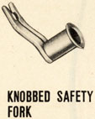
5.2 Depth Charge Pistol Mark 7 Mod. 1. Prior to installation, the Depth Charge Pistol Mark 7 Mod. 1 should be kept in a Safe condition by a flat safety fork sealed in place and by setting the dial on Safe. When pistols are to be placed in charges to be used in projectors, the seals on the shipping safety forks should be broken and short lanyards attached to the forks for stripping by hand immediately prior to firing the projector.
5.3 When pistols are to be placed in charges to be used in the tracks, the shipping safety fork of the pistol is replaced by a knobbed safety fork which is supplied in the pistol container with the pistol. When the charge is dropped from the track, the knobbed fork will be stripped off by the track wiping plate.
5.4 Before installing the pistol in the case, check the pistol to see that (a) it is cocked (the letter C showing in the inspection port), (b) a safety fork is in place on the pistol, (c) the depth-setting dial is set as S (safe). Prepare the case by removing the blanking plate and the wide shipping gasket from the nose end of the central tube (opposite the fins). See that a blanking plate is installed on the after end of the central tube with a gasket between the plate and the flange of the tube. Make sure the cap screws securing this plate are tight enough to form a water-tight joint.
36
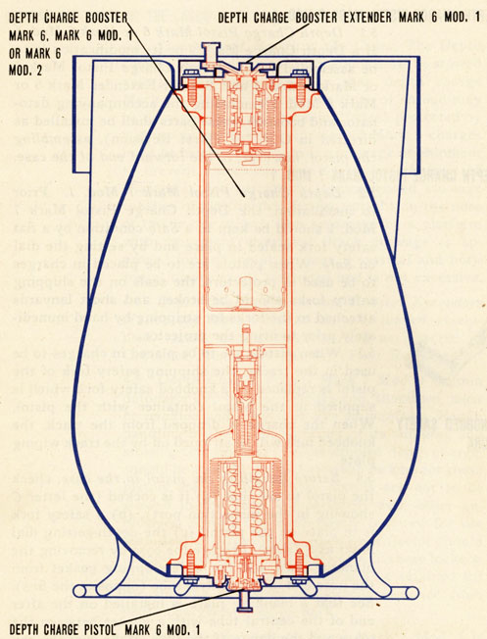
DEPTH CHARGE CASE MK, 9 OR MK, 9 MOD, 1 WITH PISTOL MK, 6 OR MK, 6 MOD, 1 AND BOOSTER EXTENDER MK, 6 OR MK, 6 MOD, 1
37
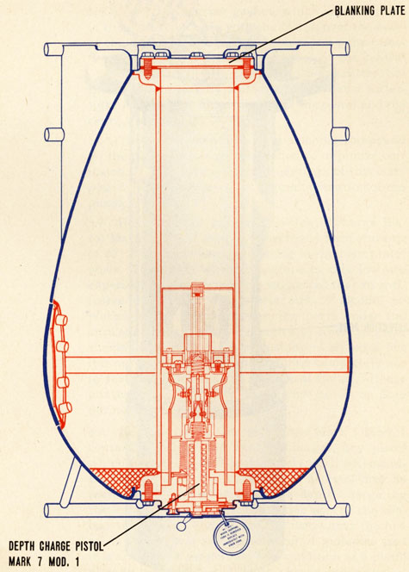
DEPTH CHARGE CASE MK, 9 MOD, 2 WITH DEPTH CHARGE PISTOL MK, 7 MOD, 1
38
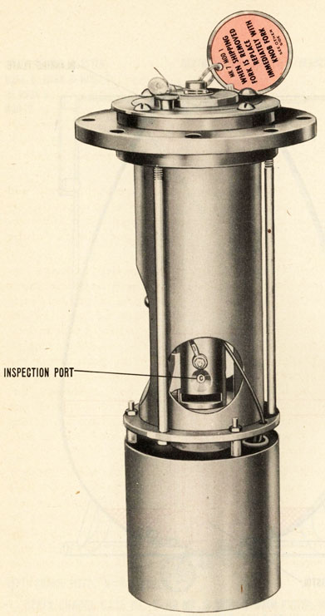
DEPTH CHARGE PISTOL MARK 7 MOD. 1
39
5.5 Place the narrow gasket, which was supplied in the pistol container with the pistol, over the body of the depth charge pistol and seat it on the pistol flange. Insert the pistol in the nose of the central tube and secure it with cap screws and washers. Set the screws up evenly and tightly so that a watertight joint will be formed between the pistol and the central tube flange.
5.6 The employment of a light slushing compound on the pistol face is recommended to minimize corrosion. Do not use excessive quantities of this compound as this may produce sluggish operation of the pistol.
5.7 Uncertain operation of the Depth Charge Pistol Mark 7 Mod. 1 may be expected at temperatures of 20 F. or lower because of icing in the pistol inlet ports. Therefore, when temperatures this low are experienced or expected, it is suggested that an antifreeze mixture of 2/3 glycerin and 1/3 alcohol be placed in the pistol through the ports under the anticountermining ring. Enough anti-freeze mixture should be inserted to allow slushing of all parts, but it is not necessary to fill the chamber completely nor to seal the pistol against leakage of the anti-freeze mixture. Caution: The pistol must be set on Safe during this operation.
5.8 Because Depth Charge Pistols Mark 7 Mod. 1 contain detonator and booster charges, any pistol which becomes armed prematurely shall be considered dangerous. The condition of a pistol may be seen, before it is assembled in a depth charge, by the letter showing in the inspection port of the sub-booster carrier. The letter C indicates that the pistol is cocked and safe. The letter A indicates that it is armed and dangerous. The condition of a pistol already assembled in a depth charge can be noted by the position of the outer end of the piston rod
40
with relation to the anti-countermine valve. If the piston rod protrudes through the valve so that a safety fork may be placed. on it, the pistol is safe. If the end of the rod is flush with, or inside, the valve, the pistol is probably armed and must be considered dangerous. DO NOT ATTEMPT TO DISASSEMBLE OR DISARM AN ARMED PISTOL. TO DO SO MAY CAUSE AN EXPLOSION OF THE DETONATOR AND BOOSTER CHARGES. Any pistol which has become armed, or is damaged so that it might become armed, should be destroyed. The pistol may be removed from a depth charge by removing the cap screws securing it in the central tube and pulling the pistol gently out of the tube. Precautions must be taken to see that it is not dropped or struck during removal. The exact manner of destroying the pistol is left to the discretion of the Officer in Charge. The simplest means of accomplishing this at sea is to throw the pistol overboard.
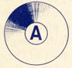  ARMED POSITION  (DANGEROUS) |   COCKED POSITION  (SAFE)

41
INSTRUCTIONS FOR USE | CHAPTER 6

INSTRUCTIONS FOR USE OF DEPTH CHARGES MARK 9 AND MODIFICATIONS
6.1 The depth-setting dials of all depth charge pistols should be kept on the SAFE setting at all times until they are adjusted for immediate use. If a charge is accidentally released in this condition it will not fire. When depth-settings are specified by the Commanding Officer, the setting dials may be turned to the desired positions.
6.2 Depth Charges Mark 9 or modifications must be handled carefully to prevent damage to the support rings and shrouds. Any deformation of the rings or shrouds may cause depth charges to jam in the release tracks. The charges should be inspected carefully for damage before loading into the tracks. Slight damage should be repaired by judicious application of force before use in a track. If a depth charge is deformed, but not badly damaged, it is recommended that the charge be thrown from a projector, rather than rolled from a track.
DROPPING FROM A RELEASE TRACK
6.3 Dropping from a Release Track. The shape of Depth Charges and modifications is such that the detents of the release traps of most types of release tracks will not bear against the cases evenly unless the tracks have been modified. The Bureau of
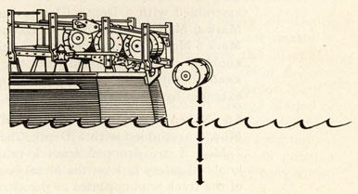
Drawing of depth charge dropping from rack.
42
Ordnance has issued instructions (Bureau of Ordnance Circular Letter No. M5-43) for the modification of release tracks to accommodate Depth Charges Mark 9 and modifications.
6.4 When placing Depth Charges Mark 9 or modifications in a release track, orient them so that the pistol which is assembled in the nose of the case is at the most accessible side of the track (usually the inboard side) to facilitate setting the firing depth of the pistol before the charge is dropped.
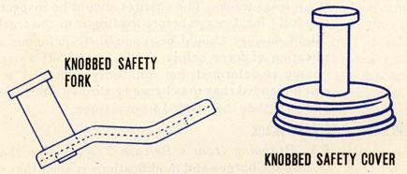
6.5 When Depth Charges Mark 9 or modifications assembled with a Depth Charge Pistol Mark 6 or Mark 6 Mod. 1 and a Booster-Extender Mark 6 or Mark 6 Mod. 1 are dropped from a release track, the knobbed cover is stripped from the pistol and the knobbed safety fork is stripped from the booster-extender by the track wiping plates.
6.6 When Depth Charges Mark 9 Mod. 1 or Mark 9 Mod. 2 assembled with a Depth Charge Pistol Mk. 7 Mod. 1 are dropped from a release track, the knobbed safety fork on the pistol is stripped by one of the track wiping plates as the charge is released.
43
FIRING FROM A PROJECTOR
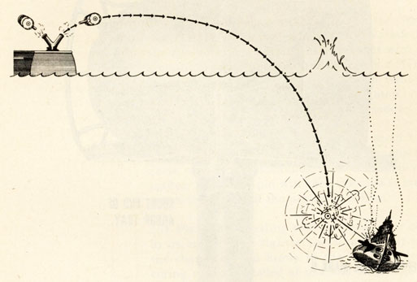
FIRING FROM A PROJECTOR
6.7 Firing from a Projector. A releasable Depth Charge Arbor Mark 7 or Mark 7 Mod. 1 is required for satisfactory firing of Depth Charges Mark 9 or modifications from a "K" or "Y" gun projector.
6.8 Because the centers of gravity of Depth Charges Mark 9 and Mark 9 Mod. 1 are relatively near the linear centers of the cases, the offset feature of the Arbor Mark 7 or Mark 7 Mod. 1 is not required. Therefore, when using an Arbor Mark 7 or a Mark 7 Mod. 1 with a Depth Charge Mark 9 or Mark 9 Mod. 1 the charge should be mounted with the center of its length in line with the longitudinal axis of the arbor stem and the stop in position marked "Unweighted charges" on the longer end of the arbor saddle.
44
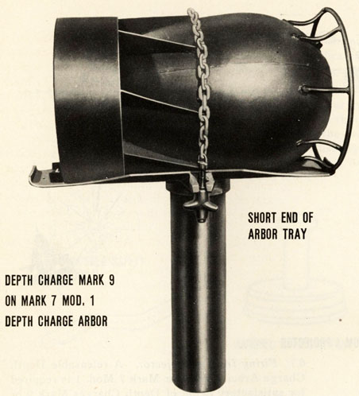
Depth Charge Mark 9 On Mark 7 Mod. 1 Depth Charge Arbor
6.9 The center of gravity of the Depth Charge Mark 9 Mod. 2 is about 11 to 11-1/2 inches from the nose. In this case the offset feature of the arbor is required, and the charge must be mounted with the nose against the stop in position marked "Weighted Charges" on the shorter end of the arbor saddle.
6.10 A depth charge may be secured in the arbor either before or after the arbor is placed in the projector. Secure the charge in the arbor as follows:
(a) See that the movable stop is on the proper end of the arbor saddle for the type of charge being loaded (see pars. 6.8 and 6.9).

45
(b) Place the charge on the arbor. If the charge is a Mark 9 or Mark 9 Mod. 1, the orientation of the charge in the saddle is unimportant with the stop in correct position. If the charge is a Mark 9 Mod. 2, it must be placed in the arbor with the nose support ring against the movable stop in position on the shorter end of the arbor saddle.
(c) Place the securing chain or cable around the charge. See that the latch release in the chain or cable is properly assembled, with a shear pin installed. The shear pin will keep the release mechanism latched until the projector is fired.
(d) Place the adjusting stud of the chain or cable in its bracket and tighten the securing nut until the charge is held firmly in the saddle. The securing nut is threaded at one end only. The nut should be placed on the stud threaded end first.
6.11 When the charge and arbor are placed in a projector, the link on the end of the release mechanism chain should be slipped through the sea lashing hook on the barrel of the projector so that it will hold when the charge is fired. The sudden strain on the chain from firing will shear the pin and allow the release mechanism to operate. Unless the projector is to be fired immediately, the charge and arbor should be lashed to the lashing hooks on the projector with either three turns of spun yarn (minimum breaking strength-305 pounds) or five turns of Navy marline (minimum breaking strength-175 pounds). The lashing need not be cut before firing the projector. The arbor release mechanism should be kept well greased as a precaution against corrosion which might prevent the mechanism from releasing when fired.
46
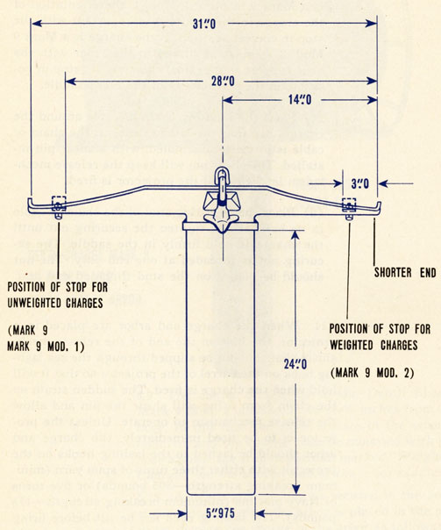
GENERAL ARRANGEMENT
47
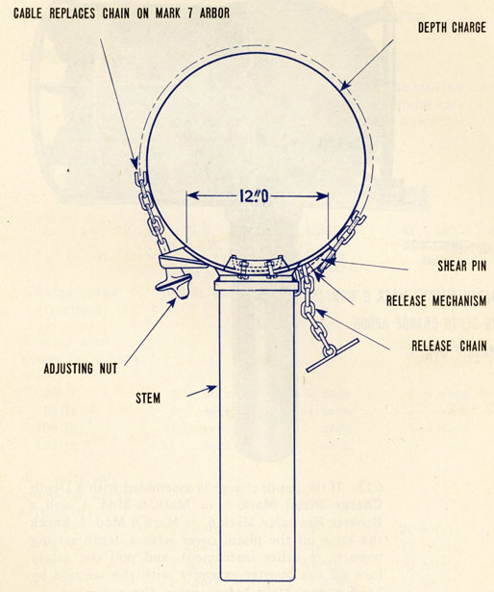
48
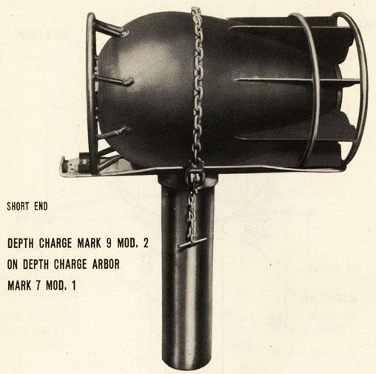
Depth Charge Mark 9 Mod. 2 On Depth Charge Arbor Mark 7 Mod. 1
6.12 If the depth charge is assembled with a Depth Charge Pistol Mark 6, or Mark 6 Mod. 1, and a Booster Extender Mark 6, or Mark 6 Mod. 1, knock the knob off the pistol cover with a depth setting wrench, or other instrument, and pull the safety fork off the booster-extender with the lanyard by hand immediately before firing the projector.
6.13 If the depth charge is assembled with a Depth Charge Pistol Mark 7 Mod. 1, remove the safety fork with the lanyard by hand immediately before firing the projector.
49
OPERATIONAL CHARACTERISTICS | CHAPTER 7

OPERATIONAL CHARACTERISTICS OF DEPTH CHARGE MARK 9 AND MODIFICATIONS
LAUNCHING SPEEDS
7.1 Launching Speeds. Table 2 gives the sinking speeds of the depth charges and the minimum safe speed of the launching vessel in deep water for shallow depth settings of these charges.
TABLE 2
 | MK. 9,  MK. 9 MOD. 1  OR MK. 9 MOD. 2  FITTED WITH A 15 FT. SEC. SPOILER PLATE | MK. 9 MOD. 2  WITH SPOILER PLATE | MK. 9 MOD. 2
Sinking speed  (terminal) | 14.5 ft./sec. | 20 ft./sec. | 22.7 ft./sec.
Sinking time
(stern launched)
to:
30 ft. | 2-1/4 secs. | 2-1/4 secs. | 2-1/4 secs.
50 ft. | 4 secs. | 3-1/2 secs. | 3 secs.
100 ft. | 7-3/4 secs. | 6 secs. | 5-1/4 secs.
150 ft. | 11 secs. | 8-1/2 secs. | 7-1/2 secs.
Minimum safe speed for depth setting of:
30 ft. | 13 knots | 17 knots | 20 knots
50 ft. | 9 knots | 11 knots | 13 knots
100 ft. | 4 knots | 5 knots | 6 knots
150 ft. | 2 knots | 2-1/2 knots | 3 knots
7.2 The minimum speeds given in Table 2 apply for dropping single charges. There is reason to believe that some cumulative damaging effect may
50
result from a pattern in which two or more depth charges detonate within a very small time interval. No data are available at present which will enable determination of this effect and the recommendation of definite speeds. It is not believed that the increase in speed for firing patterns is very great, unless the pattern is such that there is a probability of several charges going off simultaneously.
7.3 In water under 100 feet deep, the damaging effects of shallow shots may be accentuated by reflections from the bottom. It is recommended, therefore, that the minimum speeds be increased by 2 knots when dropping depth charges in shallow water.
7.4 The data of Table 2 are values estimated on the basis of information currently available. Both the minimum safe launching speeds and the charge sinking times are on the conservative (fast) sides. The minimum safe speeds as tabulated are for normal conditions and are specified to protect the ship from structural damage or severe shock damage, but recognizes the possibility of minor damage and electrical shock troubles which will not permanently immobilize the ship or seriously impair her activities. In practice attack for depth charge test, the launching speed should be at least 2 knots greater.
EXCEPTIONS TO MINIMUM SPEEDS OF TABLE 2
7.5 Exceptions to minimum speeds of Table 2. It may be desirable under favorable conditions to risk the firing ship by dropping depth charges at slower speeds if the situation is such that this is necessary to deliver a promising attack against an enemy submarine. Under abnormal conditions (rough weather and heavy seas, ship structurally damaged, or in shallow water) somewhat higher minimum speeds should be adopted to avoid damage to the firing
51
ships. The amount of speed margin to allow in each case must be determined by the Commanding Officer, taking into consideration the degree of abnormality of conditions.
PISTOL FIRING DEPTHS
7.6 Pistol Firing Depths. The Depth Charge Pistol Mark 6 Mod. 1 was originally designed for use in Depth Charges Mark 6 or 7 which do not sink as fast as Depth Charges Mark 9 and Modifications. Unfortunately, the faster sinking charges do not permit sufficient time for the water chamber of these pistols to fill for firing at shallow depth.
7.7 Table 3 shows the depths at which Depth Charge Pistols will probably fire when used in Depth Charges Mark 9 and modifications. There may be a considerable variation from the figures given, as the actual firing depth is determined by the rate of entry of water into the pistol.
TABLE 3
 |  | ACTUAL FIRING DEPTH AND TIME IN CASE
 |  | MK. 9 OR 9-1 |  | MK. 9-2 (22.7 FT/SEC.)
PISTOL | PISTOL  SETTING | DEPTH  FT. | TIME  SEC. | DEPTH  FT. | TIME  SEC.
Mk. 6 | 30 | 45 | 3-3/4 | 60 | 3-1/2
 | 50 | 60 | 4-1/2 | 80 | 4-1/2
 | 75 | 80 | 6 | 90 | 4-3/4
 | 100 | 100 | 7-3/4 | 105 | 5-1/2
Mk. 6-1 | 30 | 85 | 6-3/4 | 110 | 5-3/4
 | 50 | 95 | 7-1/4 | 130 | 6-1/2
 | 75 | 100 | 7-3/4 | 140 | 7
 | 100 | 125 | 9-3/4 | 145 | 7-1/4
 | 150 | 150 | 10-1/2 | 165 | 8-1/4
Mk. 7-1 | 50 | 50 | 4 | 55 | 3-1/2
 | 100 | 100 | 7-3/4 | 100 | 5-1/4

52
7.8 The Depth Charge Pistol Mark 7 Mod. 1 (to be used only in the Depth Charges Mark 9 Mod. 1 or Mark 9 Mod. 2) will fire within its tolerance at the set depth.
PROJECTION RANGES
7.9 Depth Charges Mark 9 and modifications may be fired safely from side projectors at any speed with the No. 1 impulse charge, provided that the impulse charge does not give less than 30 yards range for any reason such as excessive rolling or improper performance of the charge. Table 4 gives the normal ranges and estimated times of flight of the Depth Charges Mark 9 and modifications when fired from projectors.
TABLE 4
IMPULSE  CHARGE | RANGE | ESTIMATED  TIME OF  FLIGHT
#1 | 60 yds. | 3.4 seconds
#2 | 90 yds. | 4.2 seconds
#3 | 150 yds. | 5.1 seconds
7.10 The information contained in this chapter on minimum safe launching speeds is based upon information furnished by the Bureau of Ships.
53
APPENDIX A

DRAWINGS PERTAINING TO DEPTH CHARGES MARK 9 AND MODIFICATIONS
 | LIST OF  DRAWINGS  SKETCH  NUMBER | GENERAL  ARRANGEMENT  DRAWINGS  NUMBER
(a) Mk. 9-
(1) Depth Charge Assembly | 55553 | 362685
(2) Case | 55478 | Sk. 112173
(b) Mk. 9 Mod. 1-
(1) Depth Charge Assembly |  | Mu.Sk. 25789
(2) Case | 130645 | 383906
(c) Mk. 9 Mod. 2-
(1) Depth Charge Assembly
(2) Case | 130590 | 383781
(d) Depth Charge Pistol-
(1) Mk. 6 |  | 204044
(2) Mk. 6 Mod. 1 |  | 328372
(3) Mk. 7 Mod. 1 | 109978-79 | 383706
(e) Booster Extender-
(1) Mk. 6 |  | 204053
(2) Mk. 6 Mod. 1 |  | 328206
(f) Booster--
(1) Mk. 6 |  | 204056
(2) Mk. 6 Mod. 1 |  | 375783
(3) Mk. 6 Mod. 2 |  | 388788
(g) Releasable Arbor-
(1) Mk. 7 |  | 375995
(2) Mk. 7 Mod. 1 |  | 388799
(h) Depth Setting Wrench |  | 389143

54
DISTRIBUTION
Requests for copies of OP 866 (1st Revision) should be addressed to the nearest BuOrd Publications Distribution Center:
Commandant and Superintendent
U. S. Naval Gun Factory, Navy Yard
Washington 25, D.C.
(Attn: OrdPubSubcen)
Commandant
Navy Yard
Mare Island, California
(Attn: OrdPubSubcen)
Commander Service Force, SEVENTH FLEET
Ordnance Publications Subcenter
c/o Fleet Post Office
San Francisco, California
Officer in Charge
Ordnance Publications Subcenter
Naval Supply Depot
Pearl Harbor, T. H.
DISTRIBUTION:
Standard Navy Distribution List No. 20
2 copies each unless otherwise noted.
1.a-e,g,h,k,l,q-t,x,z-ff,ii,ll,mm,pp,ss,tt,ww,xx,zz;2.a (Torpedo, Observation, Cruiser, Scouting & Patrol Rons only),b,c,e(CruDivs only),g,h,k,n,q,r,v ; 3.(1 copy),nn; 3.i,j,k,m,r,rl,w,y,cc; E3.; 4.(1 copy),nn; 4.i-k,m,r,w,y,cc; 5.b(Alusna,London only); 6.a-n; 7. b,c(NOB's only),f-i,p(NAD's only),r,s,u(except Naval Clothing Depot),aa,ee(Advance Base Depots only); 7.(5 copies),a(Navy Yds. only),1(DesBases only); 8.a(San Diego only),b,h(NOL and No. Beach only),i,j(except Panama City, Fla. and Neah Bay, Wash.),n(SPECIAL LIST G,K,L,P,V,AA); 10.t; 10.(25 copies),nn; 11.a(BuShips),ComdtMarCorps; 12.a,b(Revision 1); 14.a,q.

